1. **Table:**A table is a collection of records in the database. Tables contain columns, which correspond to fields in the records (or rows) on a table. Many applications use tables and records to manage data and processes, such as Incident, Problem, and CMDB. Tables can extend other tables, creating parent tables and child tables. To create your own table navigate to **System Definition > Tables & Columns**
2. **Form:**  A form displays information from one record in a data table. The specific information depends on the type of record displayed. Users can view and edit records in forms. Administrators can [customize forms](https://wiki.servicenow.com/index.php?title=Personalizing_Forms).

Administrators and users with both the form_admin and personalize_form roles can customize the layout for any form view.

# Personalizing Forms

To personalize a form:

Right-click the form header and select **Personalize > Form Layout**.

[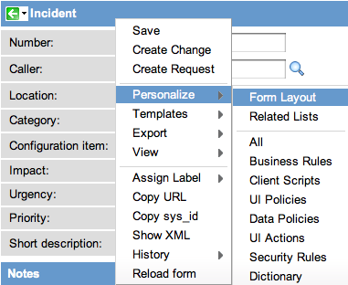](https://wiki.servicenow.com/index.php?title=File:PersonalizeFormLayout.png)

1. **Lists**: Lists display information from a data table. Users can search, sort, filter, and edit data in lists. Lists also may be embedded in forms and may be hierarchical (have sublists).

ServiceNow lets users with the *personalize_list* role (including administrators) personalize the columns in any list to show only the desired information. You can add or remove fields (columns) from a list or change the order in which the fields appear in the list. You can hide controls and define access conditions by role to existing controls. To personalize a list, bring up the list, right-click the list's header bar, and select **Personalize**. This opens a cascading menu with the following list options:

* List Layout
* List Calculations
* List Control

[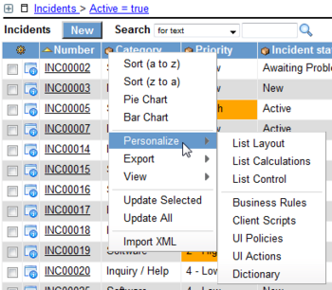](http://wiki.servicenow.com/index.php?title=File:PersonalizeListLayout1.png)

# List Layout

To change the default columns for a list view:

1. Open the list in the view you wish to modify.

For example, to modify the incident mobile view, navigate to **Incident > Open** and select **View > Mobile** from the context menu.

1. Right-click the header and select **Personalize** > **List Layout**.
2. Use the [slushbucket](http://wiki.servicenow.com/index.php?title=Slushbucket) to select the columns and the order in which you wish them to appear.

The first non-reference field automatically links to the form view of the record. For this reason, consider using the record number as the first column in the list layout.

1. **Fields:** The individual pieces of data in a record are called fields. These fields can be modified using the Record List editor, or using a form. On the form, the fields appear as fields in the form, and in the Record List view they appear as columns of data on the table.

Creating New Fields

**To add a new field:**

1. Navigate to the form of the new field's table.
2. Right click the form and select **Personalize > Form Layout**.
3. In the **Create new field** section, enter the name of the field and select the field type.

[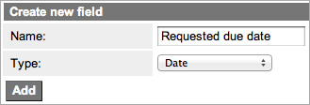](http://wiki.servicenow.com/index.php?title=File:AddNewField.png)

1. Click **Add**.
2. Use the [slushbucket](http://wiki.servicenow.com/index.php?title=Slushbucket) to place the field in the desired location on the form.
3. Click **Save**.

The field now appears on the form in the correct location.

1. **Dictionary**: The system dictionary is a table named sys_dictionary which defines all the tables and fields within the instance. The system dictionary provides customization options for tables and fields, which in turn define lists and forms.

An application menu is a group of modules, or pages, that provide related information and functionality in a ServiceNow instance. Administrators can define application menus to group modules under one name in the application navigator. Administrators can also restrict access to application and module listings.

# Creating Modules

1. Open the application menu record by using one of the following methods.
   * Navigate to **System Definition > Application Menus** and select the application menu from the list. In versions prior to [Calgary](http://wiki.servicenow.com/index.php?title=Calgary_Release_Notes), navigate to **System Definition > Applications**.
   * Right-click the application label in the application navigator and select **Edit Application**.
2. Scroll down to the **Modules** related list and click **New**.
3. Define the module by completing the fields on the form (see table).
4. Click **Submit**.

An application is a group of modules, or pages, that provide related information and functionality in a ServiceNow instance. For example, the Incident application contains modules for creating and viewing incidents; the Configuration Management application contains modules for configuring servers, databases, and networks.

The application navigator, or left-navigation bar, provides links to all applications and the modules they contain, enabling users to quickly find information and services. The hide button ([hideNav.png](http://wiki.servicenow.com/index.php?title=File:HideNav.png)) in the banner frame can be used to hide the application navigator.

Administrators can [customize](http://wiki.servicenow.com/index.php?title=Administering_Applications_and_Modules) the application navigator to provide different modules by user role, modify or define applications and modules, and change its appearance.

ServiceNow integrates with many third party applications and data sources. The most common integrations are with CMDB, Incident Management, Problem Management, Change Management, User Administration, and Single Sign-on.

A variety of techniques can be used, most notably Web Services, JDBC, LDAP, Excel, CSV, and Email, as well as any industry standard technologies that use SOAP, REST, or WSDL. Additionally, API and command-line integrations can be done using a MID Server. ServiceNow has performed the following integrations with enterprise systems and platforms.

The ServiceNow platform is based on service-oriented architecture (SOA), in which all data objects can use web services to access bi-directional data-level integration.

**Servicenow as a SaaS(Introduction):** ServiceNow is a software platform that supports IT service management and automates common business processes. This software as a service (SaaS) platform contains a number of modular applications that can vary by instance and user. ServiceNow is a leading provider of cloud-based services that automate enterprise IT operations. We focus on transforming enterprise IT by automating and standardizing business processes, transforming IT's relationship to its customers, and consolidating IT across the global enterprise. Organizations deploy our service to create a single system of record for enterprise IT, lower operational costs, and enhance efficiency. Additionally, our customers use our extensible platform to build custom applications for automating activities unique to their business requirements.

A gauge is visible on a ServiceNow homepage and can contain up-to-the-minute information about current status of records that exists on ServiceNow tables.  Gauges can be created by the ServiceNow administrator or by users of ServiceNow with the 'gauge_maker' role.  Gauges can be created from reports or from lists of records on a table and can be sorted and filtered as needed.

The homepage system provides a dashboard full of frequently used content for easy storage. The first page seen upon logging in is the user's personal homepage, and a user can store multiple personal homepages as well as accessing other global homepages that they have the rights to view. Users without roles can view only the ESS homepage. Administrators can create and manage the global homepages.

# 2 Creating a Personal Homepage

Create a personal homepage using the homepage UI in any of these ways:

* Click the "Switch to page" drop-down and select New Page...
* Customize a global homepage created by someone else. This will change the name of the page to indicate the fact that it is a personal homepage, for instance by changing "Admin" to "My Admin."

Administrators can create a personal homepage for themselves or for others using the Homepage Admin > Pages module.